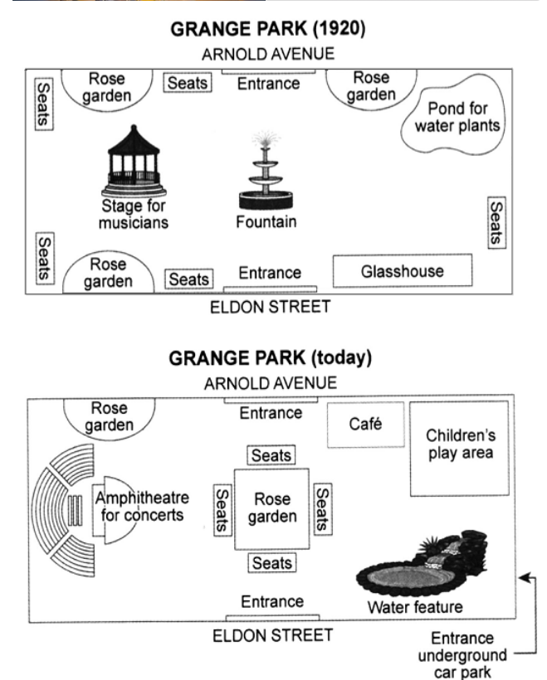

Ong Truong Dang Khoa – 520H0241

The display shows a schematic park called Grange Park which first appeared in 1920 and it has changed over time to the present day. In general, Grange park has been rebuilt in some specific places such as Stage for musicians and Fountain was replaced by Rose garden and Amphitheatre for concerts. One more detail is that there are underground car park walkways and places that look more modern than before. The two entrances on Arnold avenu and Eldon streets remain unchanged. From the entrance to Eldon Street, where you can see the center point of Grange is a rose petal beside which there are seats to rest. Next, to your right, there used to be a greenhouse that has now been replaced by a water feature. Opposite it is the children's area and the cafe that they used to grow flowers and land. Then go straight from the direction of the cafe to see the stage of the concerts called the Amphitheater which was formerly a Stage for musicians. Stand on the left side of the park from Eldon Road. It was stripped of a rose garden to make room for guests and a stage. The last thing left of Grange Park is a rose garden. In my view it looks very modern but also retains the distinctive features that not everyone can see